Object Oriented Analysis And Design Project

ShowTime Buzzer

(Android Application)



**GROUP MEMBERS**

**Shoaib Ahmed (k112016-B)**

**Muhammad Fawad Jawaid Malik (k112116-B)**

**Asad Munir (k112131-B)**

**Waheed Ahmed (k112366-B)**

***Acknowledgement***

*First of All we thank to* ***Allah SWT*** *for everything he granted us and then we thank to our teacher* ***Sir Zafar Nasir*** *for his patience and generosity in his arena of expertise, and for his valuable input. This project could not be completed without his help that he guided and assisted us in all possible ways.*

*We would like to express our special gratitude and thanks to* ***Miss Aisha Rasheed*** *and to all those who helped us to complete this project.*

Table OF Contents

Introduction 4

*About Us* 4

*Project Overview* 5

*Features* 6

Subscribe 6

Unsubscribe 6

View Collection 6

View This Week 6

Update 6

Search 7

Set Alarm tone 7

*Application Views* 7

Main Menu 7

Search Page 7

User’s Collection Page 7

Set AlarmTone Page 7

Channel Selection Page 7

Domain Model 7

USE CASE NARRATIONS 8

USE CASE DIAGRAMS 14

User Use Case Diagram 14

System Use Case Diagram 14

Complete Use Case Diagram 14

SYSTEM SEQUENCE DIAGRAMS 14

Search Show 14

Show Settings 14

Show Weekly Schedule 14

View Collection 14

Update 14

SEQUENCE DIAGRAMS 14

Subscribe 14

View Collection 14

Unsubscribe 14

Change Settings 14

ACTIVITY DIAGRAM 14

CLASS DIAGRAMS 14

GLOSSARY 14

# Introduction

## *About Us*

***Shoaib Ahmed*** *He is a Student of NUCES-FAST Karachi; enrolled in the degree of B.s (CS).He has good control over Android Application Development.Group management and Database Designing in application are done by him.*

***Muhammad Fawad Jawaid Malik*** *He is a Student of NUCES-FAST Karachi; enrolled in the degree of B.s (CS). He has been granted a full 1year Scholarship from Sindh Endownment Scholarship. He has designed and developed all layouts used in this application.*

***Waheed Ahmed*** *He is a Student of NUCES-FAST Karachi; enrolled in the degree of B.s (CS). He has been granted a full 4years Scholarship from National ICT RnDF. All System Requirement Specification in this project is done by him.*

***Asad Munir*** *He is a Student of NUCES-FAST Karachi; enrolled in the degree of B.s (CS).He has good problem solving skills. All System Design Specification in this project is done by him. He also helped in data fetching from Channels Websites.*



## *Project Overview*

*This Application notifies you with trailers updates and information about new dramas and TV Shows. The user can subscribe the show to add to his/her collection. It also alerts you about your selected TV shows before they are on-aired, this time can also be set by users. It is a complete offline application, that is, the user does not need to be always online to use this application. Although, network connection is needed to update application database, whenever there is an update in database of shows. We have categorized these shows according to TV channels. For instance, a person is out somewhere and he gets notified that one of his favorite shows will be aired after 30 minutes on specified channel. So he gets back home and never misses the show.*

## *Features*

### Subscribe

* *Adds Alarms at ‘ShowTime’ of specified show.*
* *Alarms user whenever the ‘Show’ is on-air.*
* *The Alarm can also be set by user, depending on how earlier user wants to be notified.*

### Unsubscribe

* *Removes all alarms set for the specified show.*
* *User can ‘Subscribe’ for ‘Show’ again later on.*

### View Collection

* *Shows all the ‘Shows’ subscribed by the user.*
* *User can ‘Unsubscribe’ from collection here also.*

### View This Week

* *Shows all the ‘Shows’ of a TV channel available in system sorted by days of week.*
* *User can ‘Subscribe’ to a ‘Show’ from here as well.*

### Update

* *The database of this application is updated on weekly basis.*
* *The application is updated only if there is any difference in database.*
* *User do not have to be always online to use this application.*
* *User can also check for updates from within the application.*

### Search

* *Users can also search for their desired show.*
* *The search can be filtered according to ‘Show’ Name as well as ‘Channel’ Name.*

### Set Alarm tone

* *Users can set their favorite ringtones for alarms.*
* *Alarm volumes can also be adjusted.*

## *Application Views*

### Main Menu

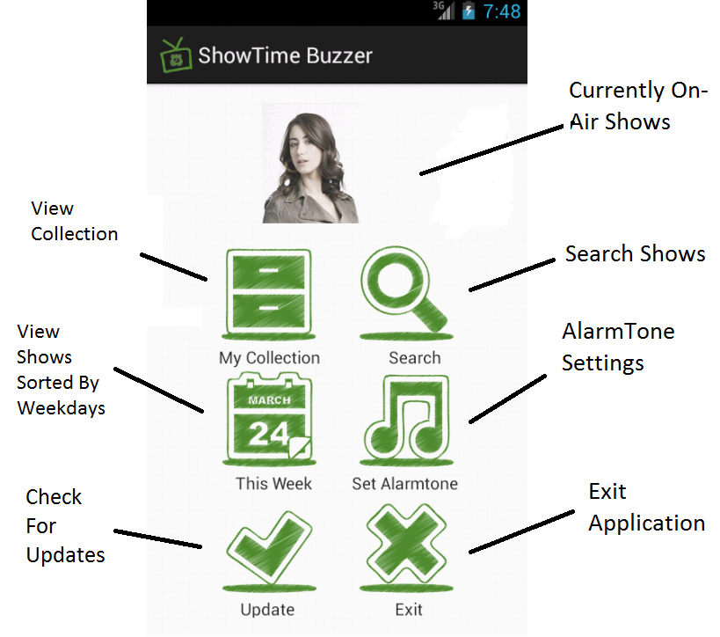

### Search Page

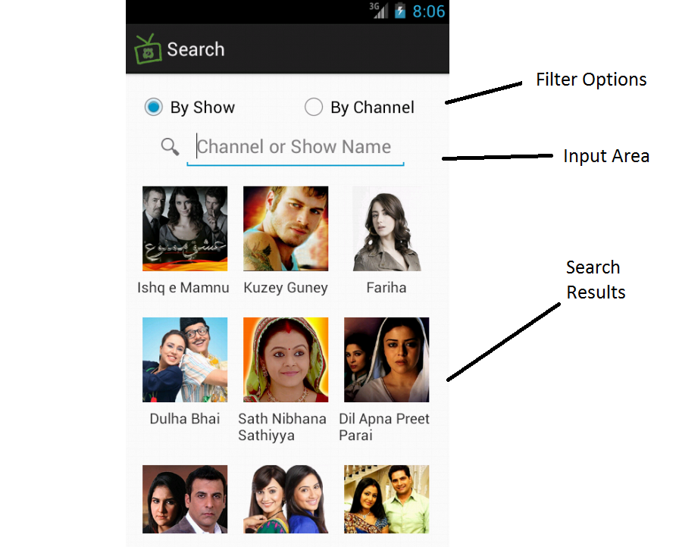

### User’s Collection Page

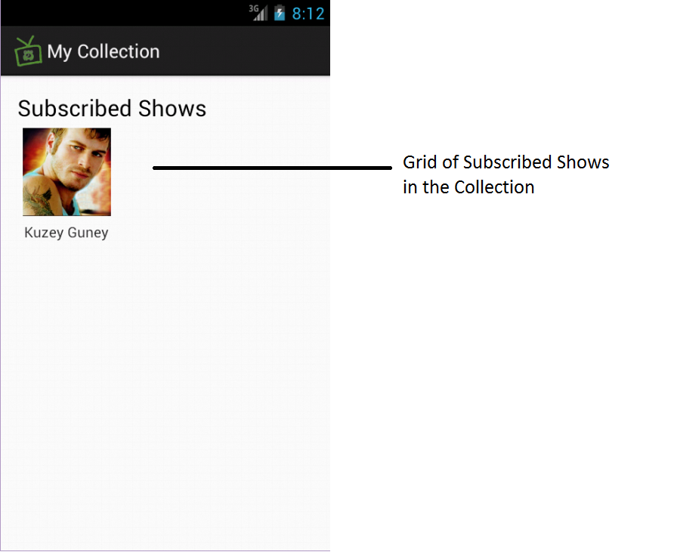

### Set AlarmTone Page

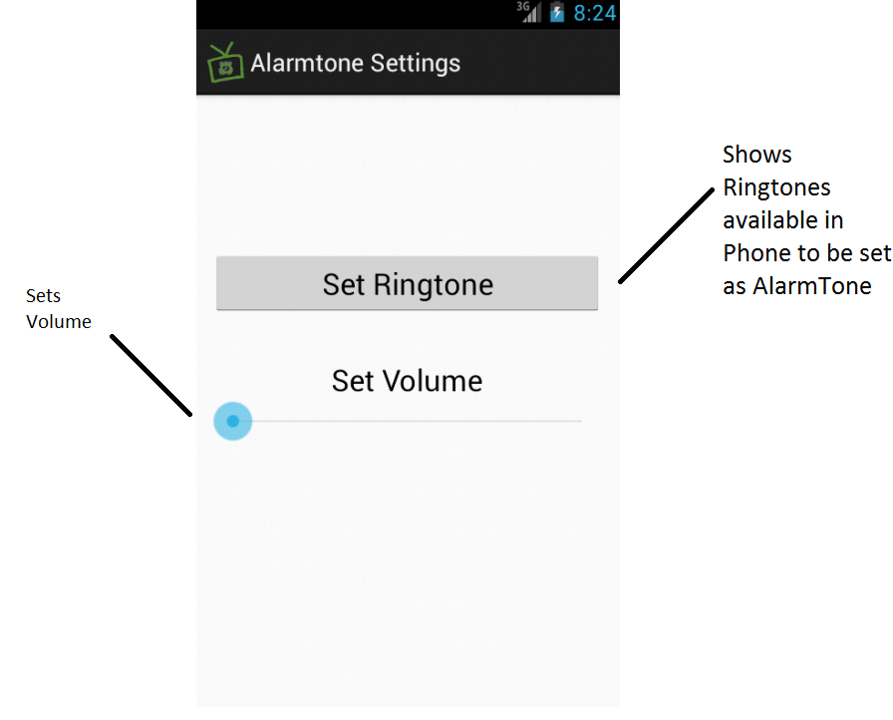

### Channel Selection Page

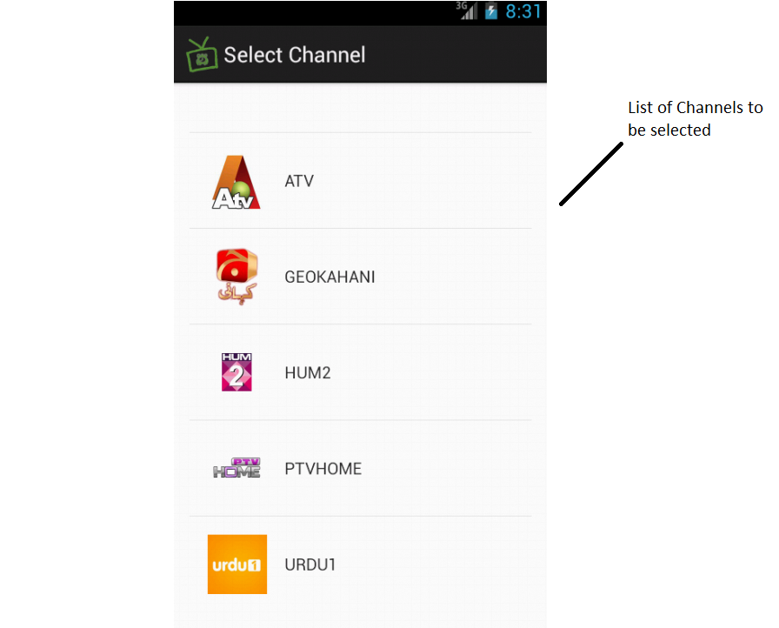

# Domain Model

# USE CASE NARRATIONS

|  |  |
| --- | --- |
| **Use Case Name:** | **Search (for shows)** |
| Brief Description | User Search for shows and can add favorite show to collection to get reminder of their favorite shows. |
| Trigger | User has to click the “Search” button |
| Pre-conditions | User is on main page screen. |
| Assumption | No |
| Primary Actors | User |
| Basic Course | * List of all available shows of all available channels will be visible to user * User select show from list |
| Alternate Course | * If Show not in list * User can update application |
| Post Condition | * User successfully got his show |
| Frequency | User can search all shows |
| Inclusive Use cases | No |
| Extend Use cases | 1. Subscribe Show. 2. Filter By Channel name 3. Filter By Show name |

|  |  |
| --- | --- |
| **Use Case Name:** | **Subscribe Show** |
| Brief Description | User can add their favorite shows to “My Collection” list to get reminder of these shows and can also set time for alarm of each show added in my collections |
| Trigger | User has to click the “subscribe” button |
| Pre-conditions | User have searched the show to subscribe |
| Assumption | No |
| Primary Actors | User |
| Basic Course | * Select show * Show page will open * Click subscribe * Set time of alarm |
| Alternate Course | No |
| Post Condition | * User successfully added show to my collections |
| Frequency | User can subscribe all shows |
| Inclusive Use cases | No |
| Extend Use cases | No |

|  |  |
| --- | --- |
| **Use Case Name:** | **Filter By Channel Name** |
| Brief Description | User can filter the search by typing channel name |
| Trigger | No |
| Pre-conditions | User is on search Screen |
| Assumption | No |
| Primary Actors | User |
| Basic Course | * User Type Channel name * User get list of shows of that channels * User selects the show and can add to collections |
| Alternate Course | * User typed invalid channel name or channel not available in list * User view through all available shows or can check for updates * Select show from available list |
| Post Condition | * User successfully got list of all shows of typed channel name |
| Frequency | Unlimited |
| Inclusive Use cases | No |
| Extend Use cases | No |

|  |  |
| --- | --- |
| **Use Case Name:** | **Filter By Show Name** |
| Brief Description | User can filter the search by typing show name |
| Trigger | None |
| Pre-conditions | User is on Search Screen |
| Assumption | None |
| Primary Actors | User |
| Basic Course | * User Type Show name * User get show * User selects the show and can add to collections |
| Alternate Course | * User typed invalid show name or show not available in list * User view through all available shows or can check for updates * Select show from available list |
| Post Condition | * User successfully got show |
| Frequency | Unlimited |
| Inclusive Use cases | None |
| Extend Use cases | None |

|  |  |
| --- | --- |
| **Use Case Name:** | **View Weekly Schedule** |
| Brief Description | User can view the whole week schedule of all channels and can add their favorite shows to “my collection” to get reminder of shows |
| Trigger | User Click View weekly schedule button |
| Pre-conditions | User is on main menu Screen |
| Assumption | None |
| Primary Actors | User |
| Basic Course | * User Click on view weekly schedule * Select channel to get schedule of, from list * Schedule of all shows of selected channels will be available * User select the show can add to “my collection” |
| Alternate Course | None |
| Post Condition | * User successfully got schedule of channel |
| Frequency | Unlimited |
| Inclusive Use cases | None |
| Extend Use cases | Subscribe Shows |

|  |  |
| --- | --- |
| **Use Case Name:** | **View My Collection** |
| Brief Description | User can check the shows that are in users collection to reset alarm time or to remove any show from list of “my collection” |
| Trigger | User Click My Collection button |
| Pre-conditions | User is on main menu Screen |
| Assumption | None |
| Primary Actors | User |
| Basic Course | * User get list of all available shows along with their cannel names * Select a show from list to view details |
| Alternate Course | None |
| Post Condition | * User successfully got list of favorites show |
| Frequency | Unlimited |
| Inclusive Use cases | None |
| Extend Use cases | Unsubscribe Show |

|  |  |
| --- | --- |
| **Use Case Name:** | **Unsubscribe Show** |
| Brief Description | User can check the shows that are in users collection to reset alarm time or to remove any show from list of “my collection” |
| Trigger | Click remove show |
| Pre-conditions | User is on my collection Screen |
| Assumption | None |
| Primary Actors | User |
| Basic Course | * User have list of all available shows along with their cannel names * Select a show from list to view details * Remove show from list |
| Alternate Course |  |
| Post Condition | * User successfully removed show from list |
| Frequency | Unlimited |
| Inclusive Use cases | None |
| Extend Use cases |  |

|  |  |
| --- | --- |
| **Use Case Name:** | **Set Alarm Tune** |
| Brief Description | User can update its setting of alarm like change alarm tune or volume |
| Trigger | User Click Set alarm tune button |
| Pre-conditions | User is on main menu Screen |
| Assumption | None |
| Primary Actors | User |
| Basic Course | * User click Set alarm Tune * Review current settings * Update current Setting |
| Alternate Course |  |
| Post Condition | * User successfully updated current settings |
| Frequency | Unlimited |
| Inclusive Use cases | None |
| Extend Use cases | 1. Set Ring Tune 2. Adjust Volume |

|  |  |
| --- | --- |
| **Use Case Name:** | **Set Ring Tune** |
| Brief Description | User can change the rig tune of alarm |
| Trigger | User Click Set ring tune button |
| Pre-conditions | User is on Set Alarm Tune menu Screen |
| Assumption | None |
| Primary Actors | User |
| Basic Course | * User click Set ring tune * Select tune from available list * Save changes |
| Alternate Course | None |
| Post Condition | * User successfully updated ring tune settings |
| Frequency | Unlimited |
| Inclusive Use cases | None |
| Extend Use cases | None |

|  |  |
| --- | --- |
| **Use Case Name:** | **Set Volume** |
| Brief Description | User can adjust the volume settings for alarm tune |
| Trigger | User Click Set volume button |
| Pre-conditions | User is set alarm tune Screen |
| Assumption | None |
| Primary Actors | User |
| Basic Course | * User click Set volume * Review current settings * Change volume * Save changes |
| Alternate Course |  |
| Post Condition | * User successfully updated volume settings |
| Frequency | Unlimited |
| Inclusive Use cases | None |
| Extend Use cases | 1. Set Ring Tune 2. Adjust Volume |

|  |  |
| --- | --- |
| **Use Case Name:** | **Update** |
| Brief Description | User can update application to get the updated shows and time whenever user want to update and system will automatically update application after a fix interval of time |
| Trigger | User Click update button |
| Pre-conditions | User is on main menu Screen |
| Assumption | None |
| Primary Actors | User, system |
| Basic Course | * User click on update button * System will check for updates and automatically make changes if available. * Application restarted |
| Alternate Course | * System will check and if no updates available then restart application without updating |
| Post Condition | * User successfully updated application. |
| Frequency | Unlimited |
| Inclusive Use cases | None |
| Extend Use cases | None |

|  |  |
| --- | --- |
| **Use Case Name:** | **Exit** |
| Brief Description | It’s a button to quit application |
| Trigger | User Click Exit button |
| Pre-conditions | Application is running and user is on main menu Screen |
| Assumption | None |
| Primary Actors | User |
| Basic Course | * User click on exit button * System will prompt user to select yes for quit * User click on yes * Application closed |
| Alternate Course | * If user select option “No” on prompt the application will not closed * User bought back to main menu screen |
| Post Condition | * User successfully quit application. |
| Frequency | Once when application is running |
| Inclusive Use cases | None |
| Extend Use cases | None |

# USE CASE DIAGRAMS

## User Use Case Diagram

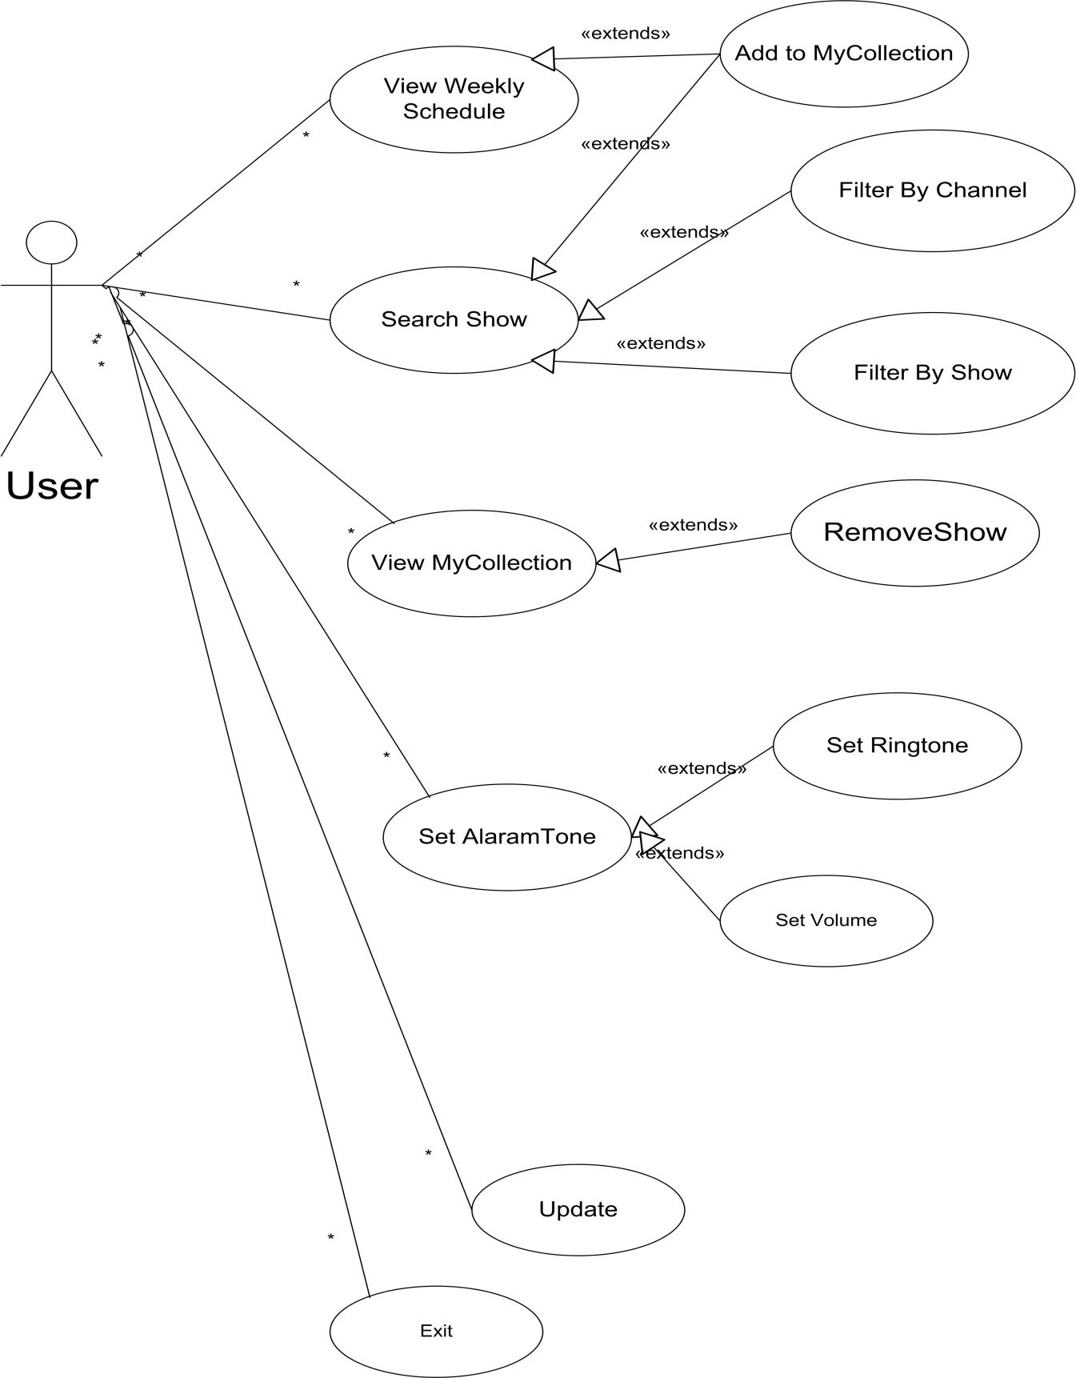

## System Use Case Diagram

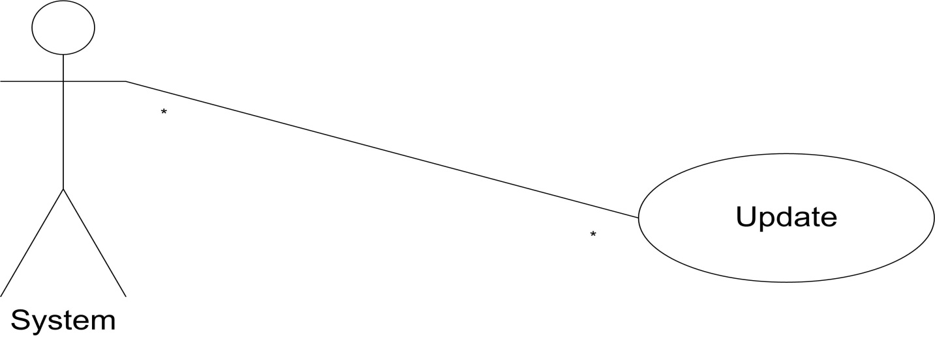

## Complete Use Case Diagram

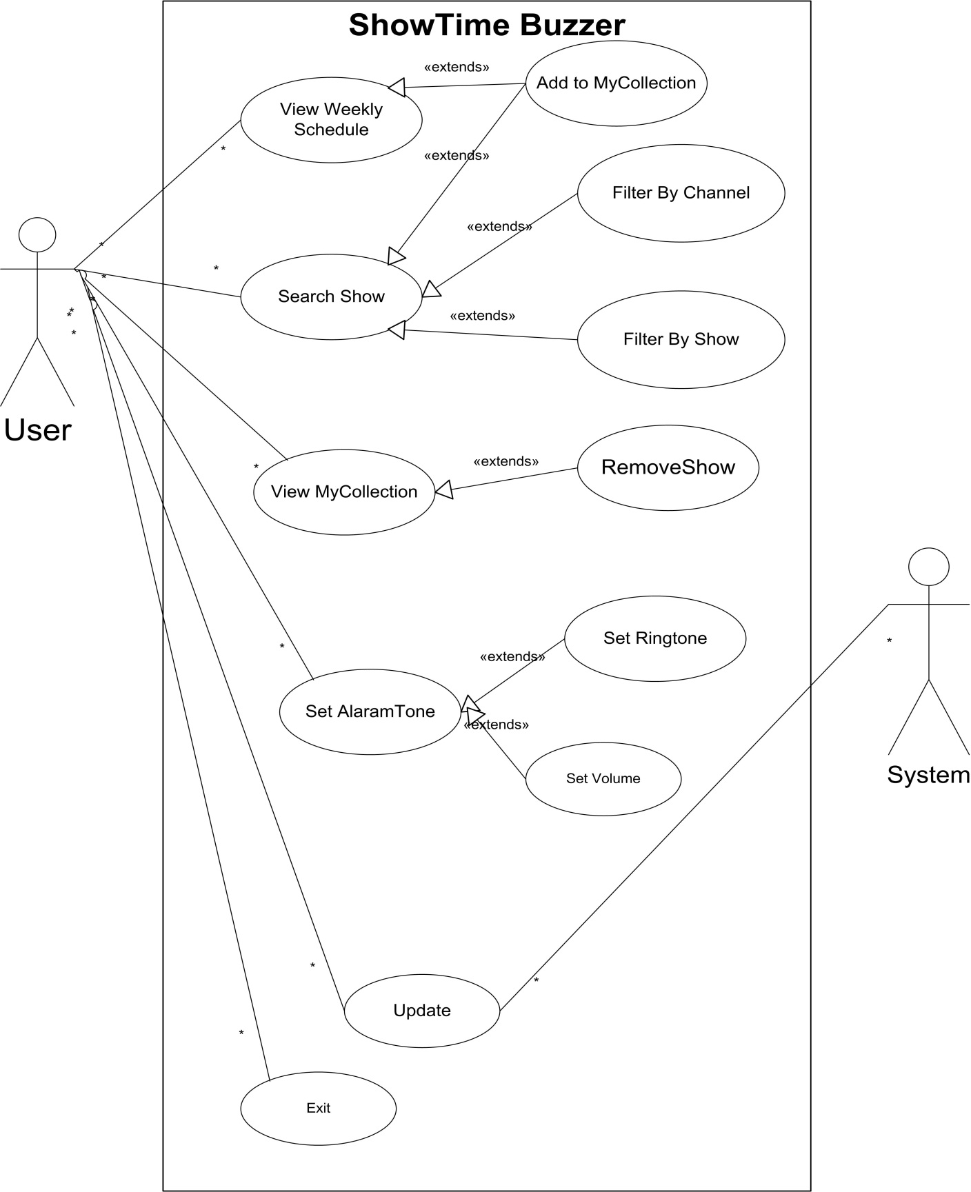

# SYSTEM SEQUENCE DIAGRAMS

## Search Show

## Show Settings

## Show Weekly Schedule

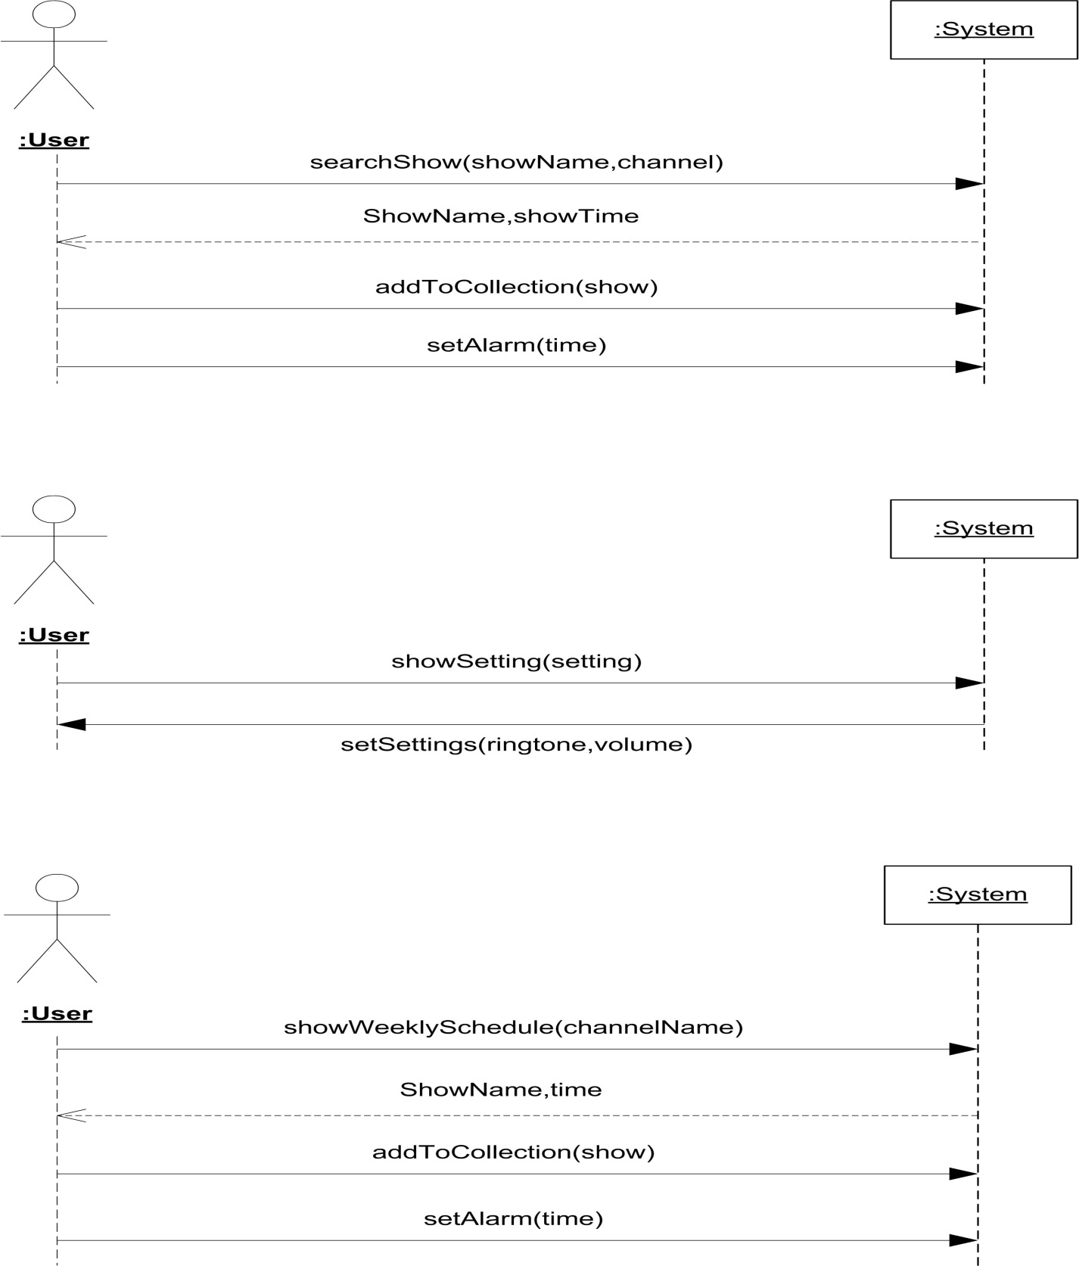

## View Collection

## Update

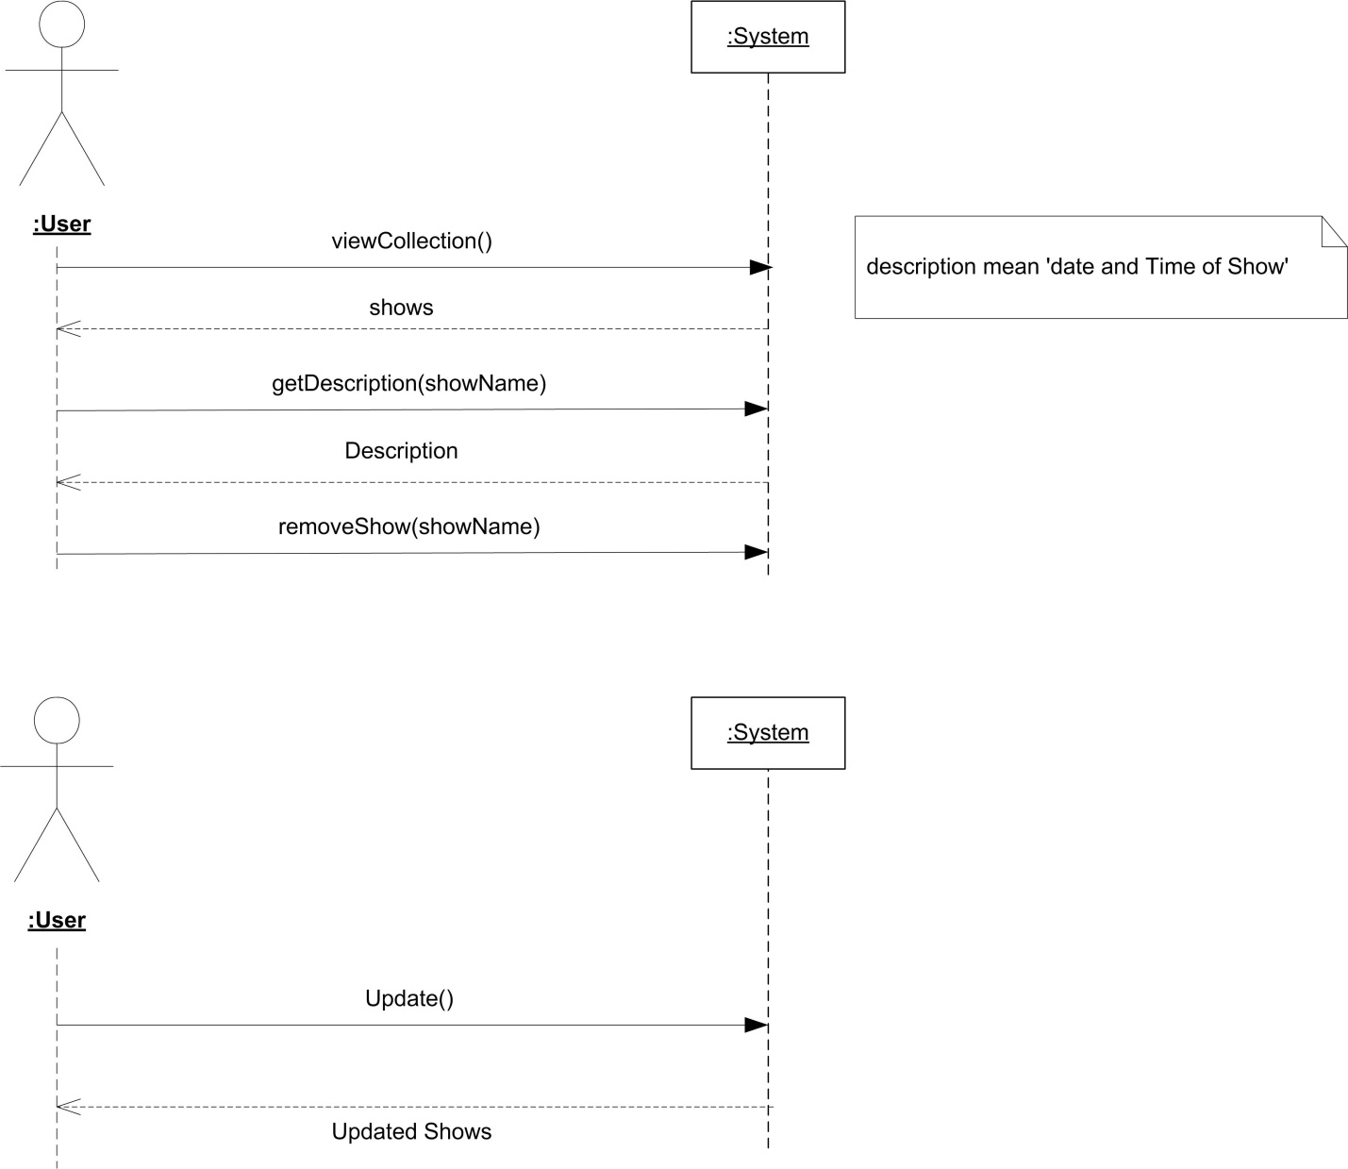

# SEQUENCE DIAGRAMS

## Subscribe

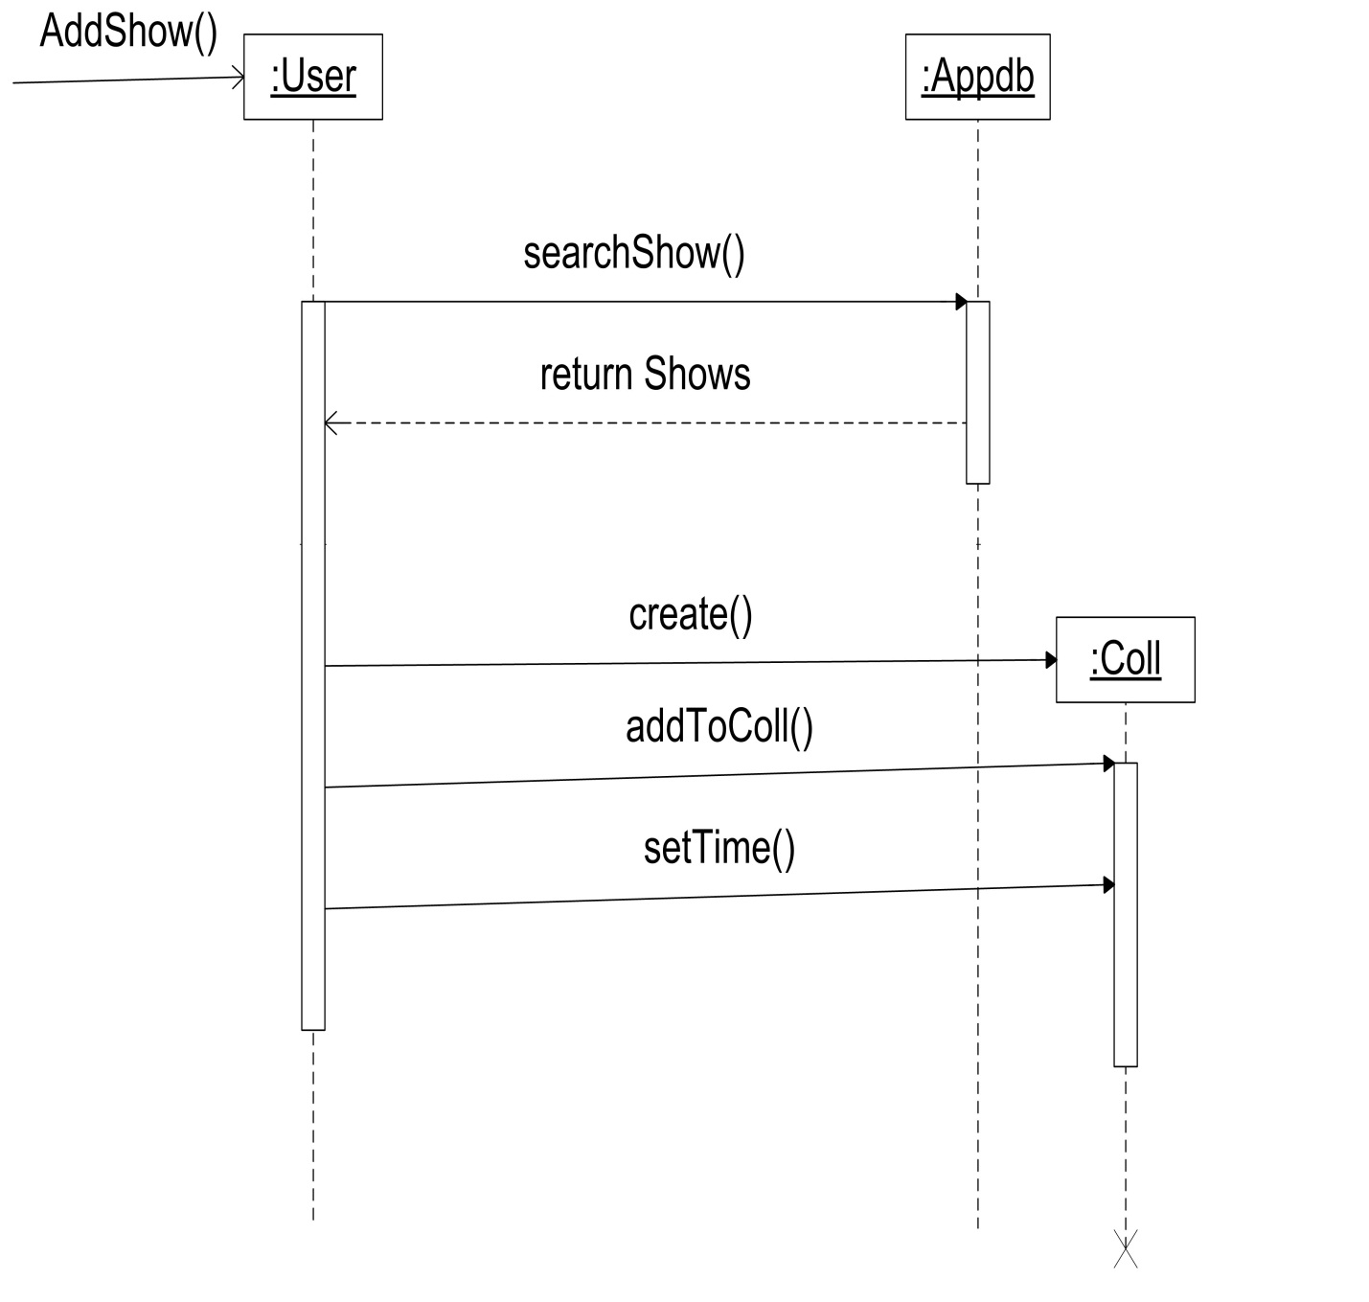

## View Collection

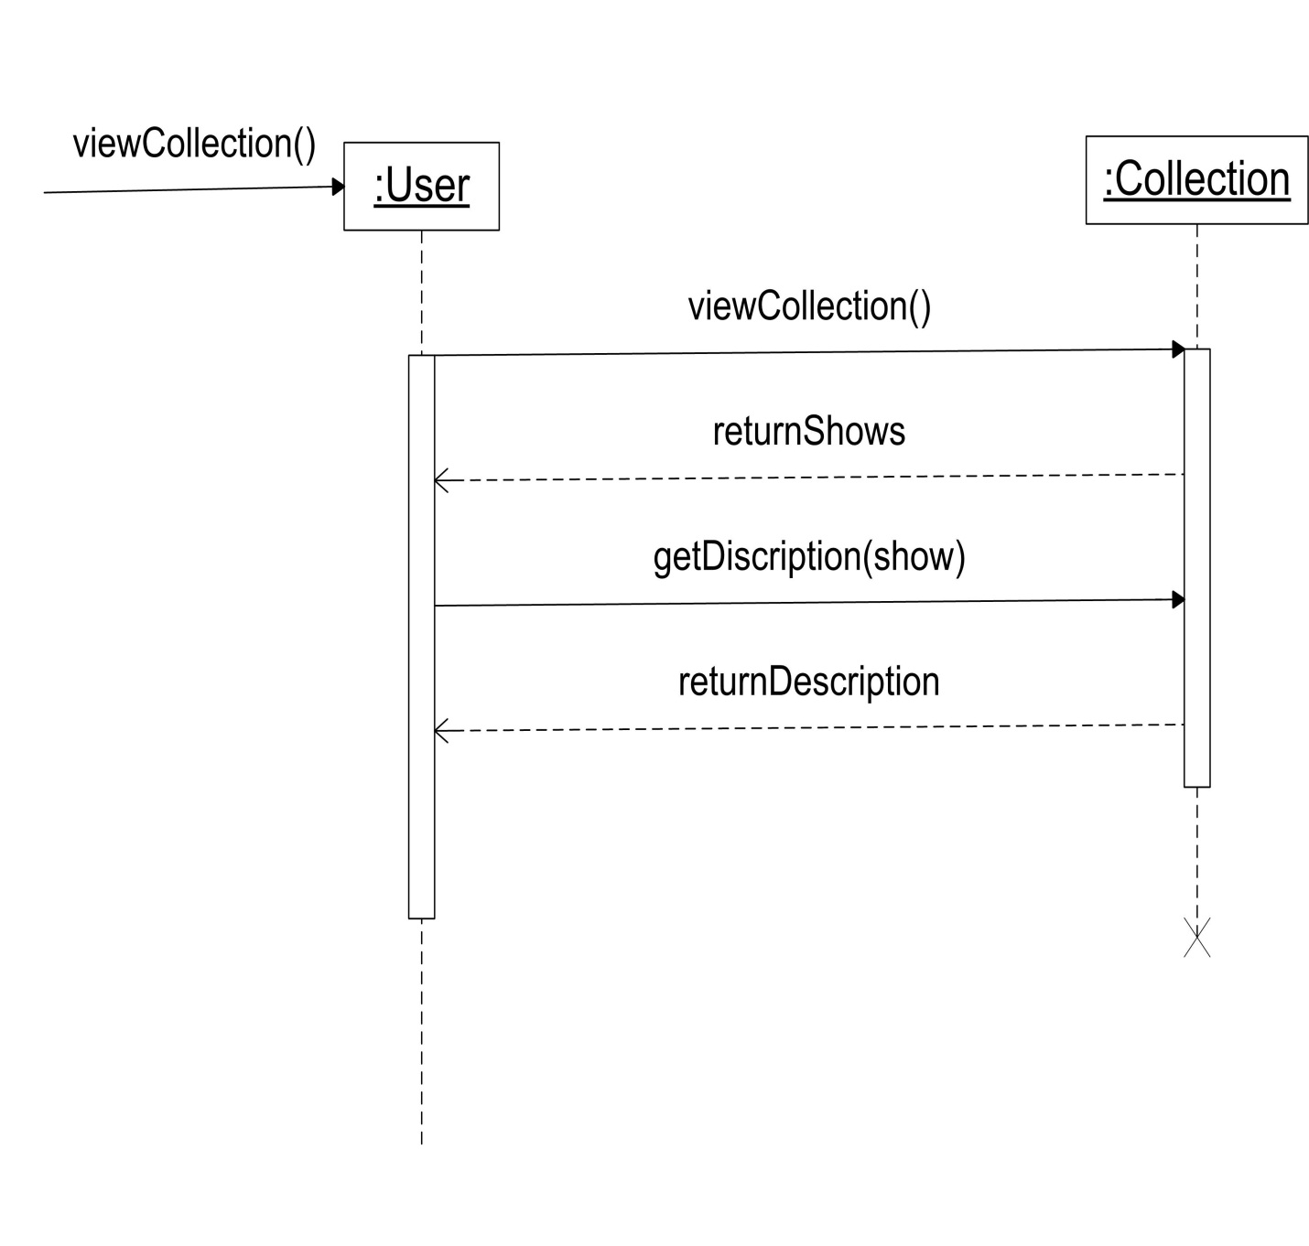

## Unsubscribe

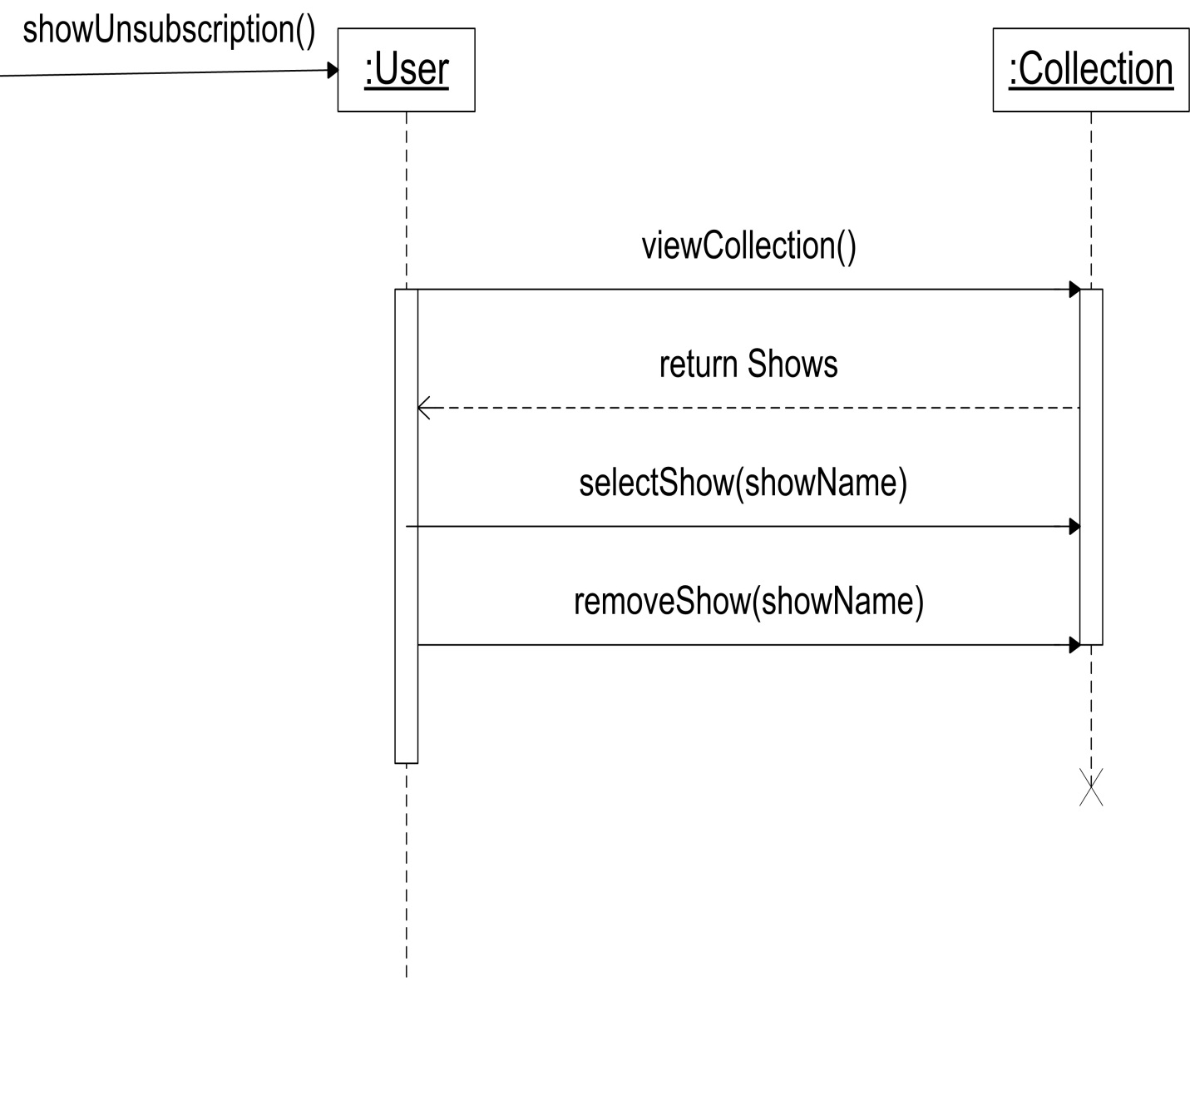

## Change Settings

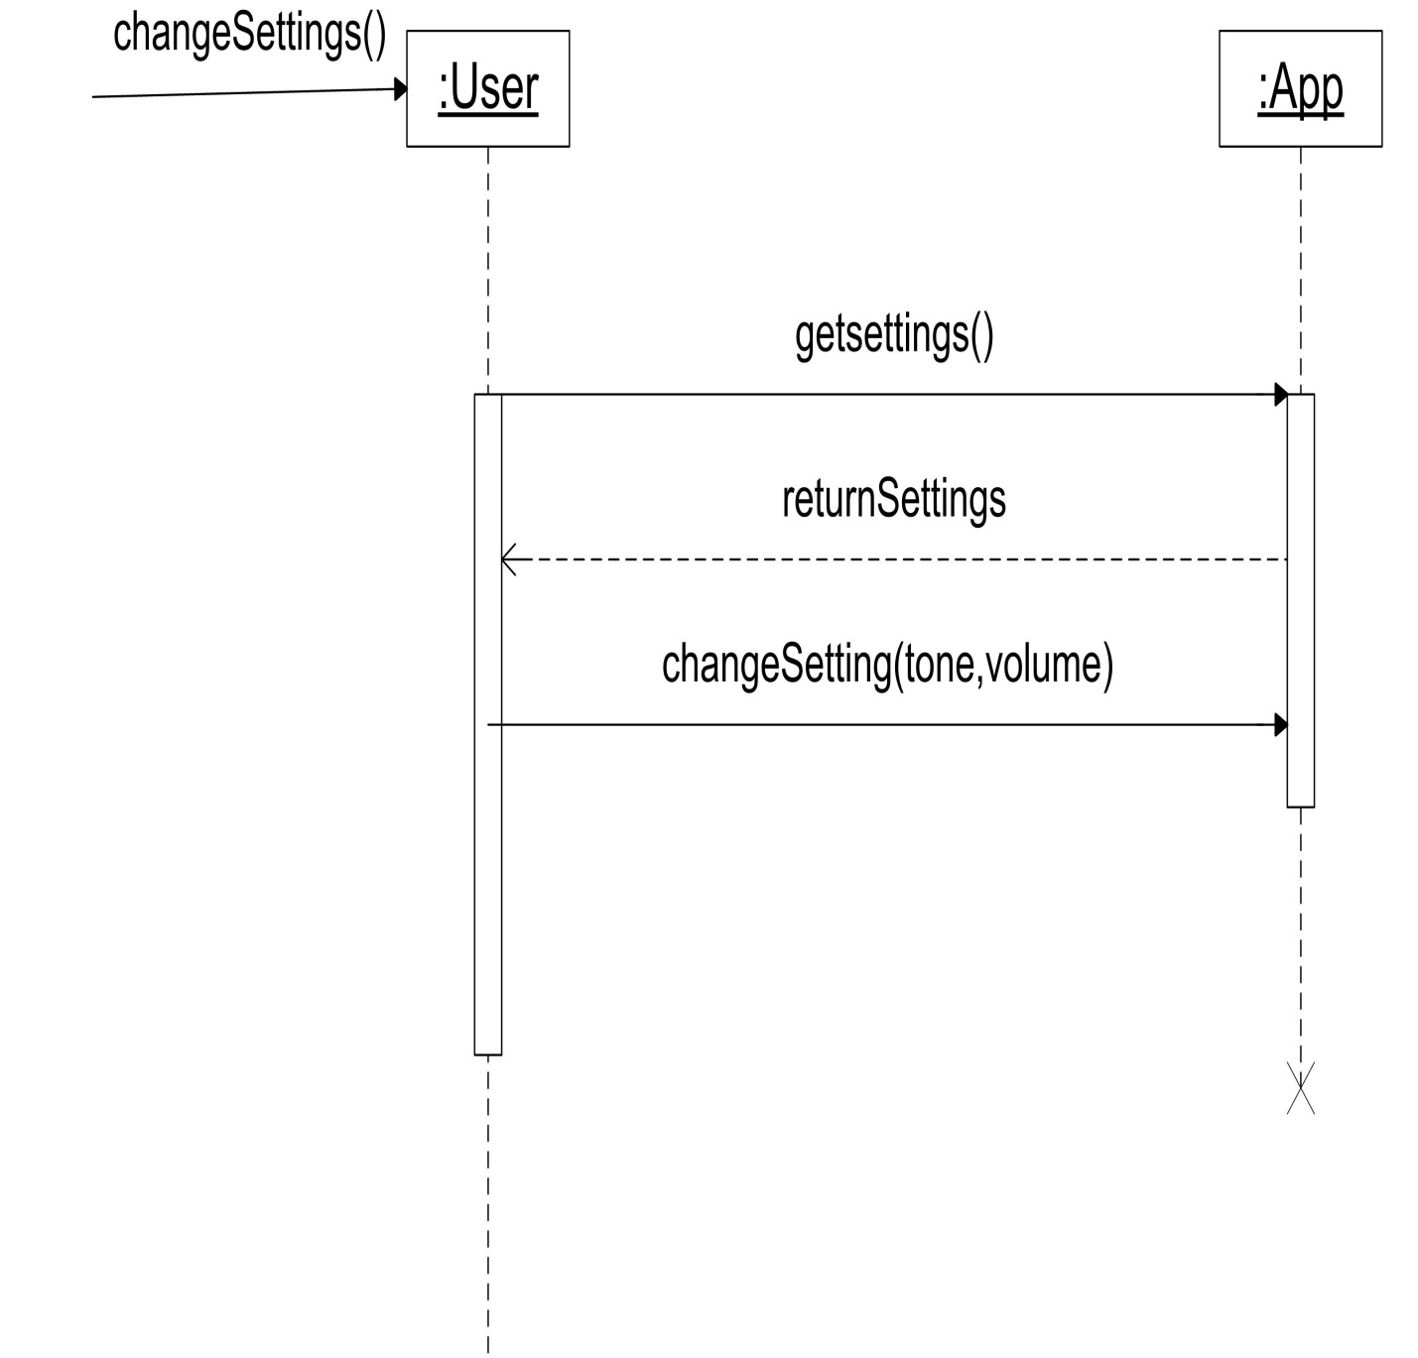

# ACTIVITY DIAGRAM

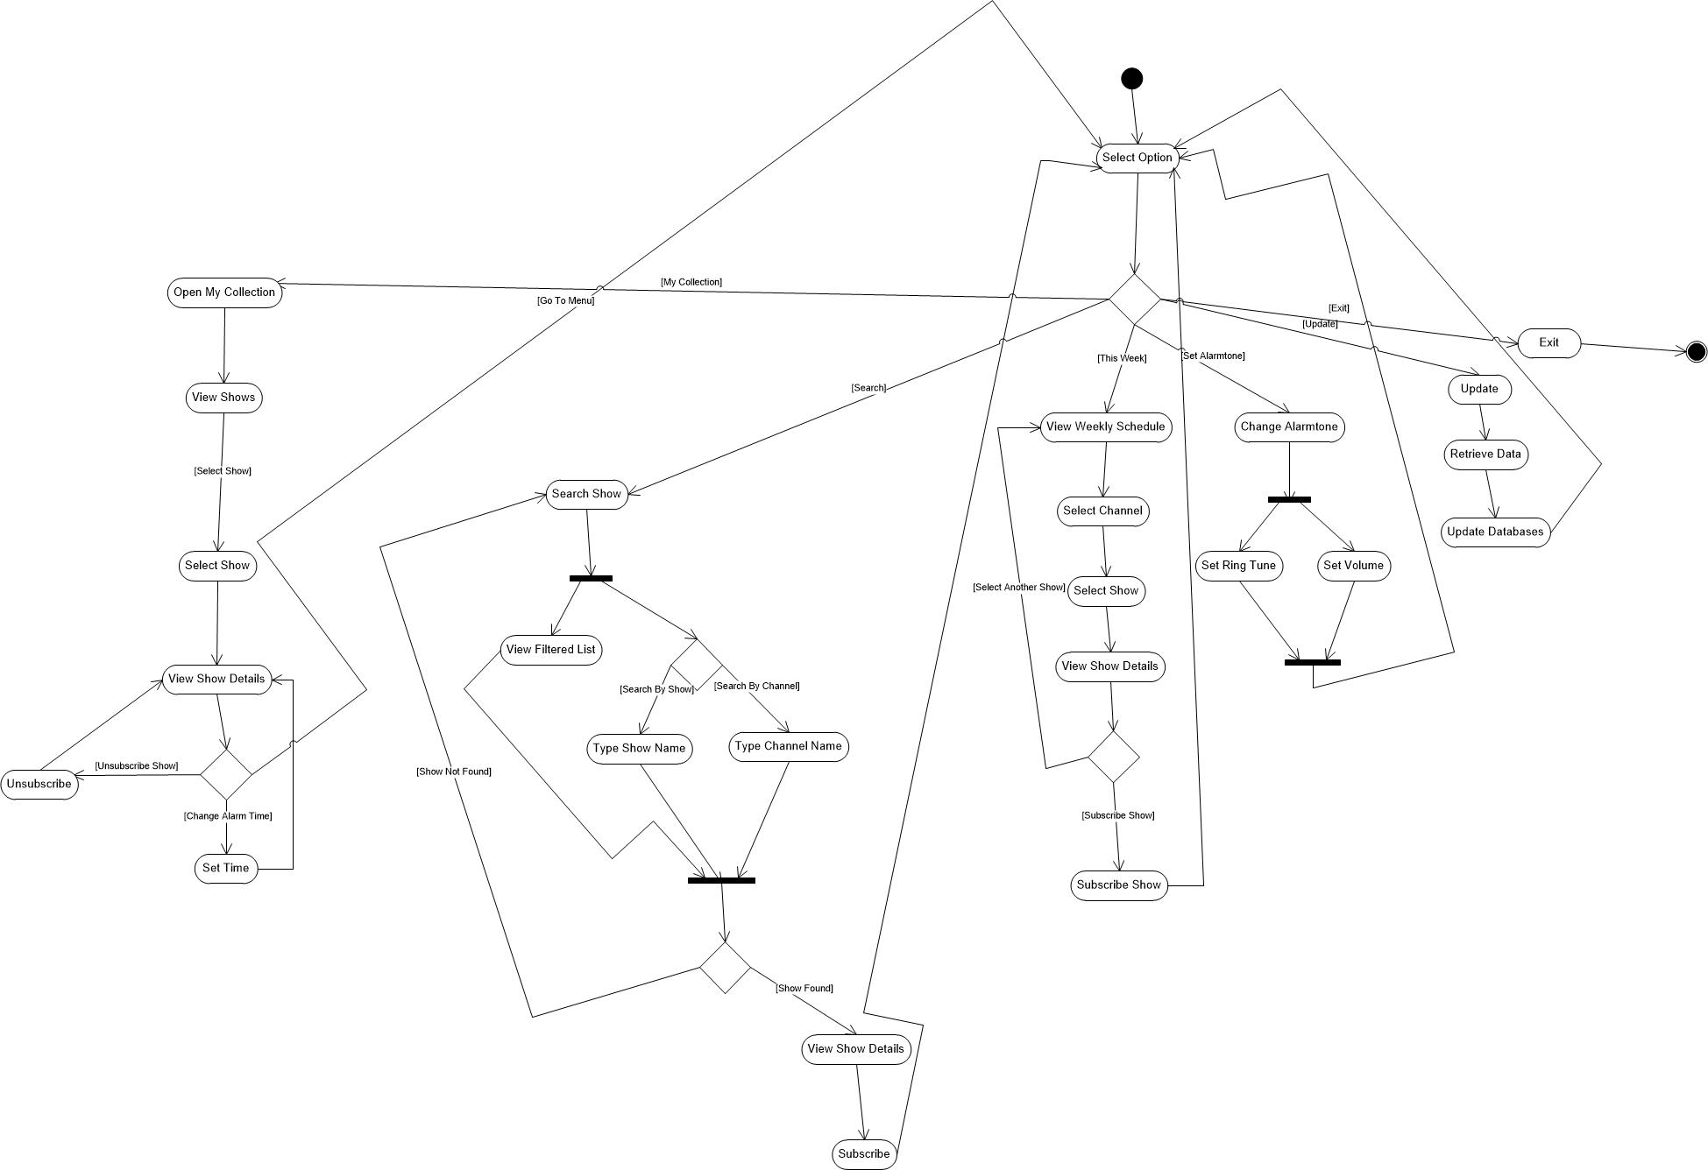

# CLASS DIAGRAMS

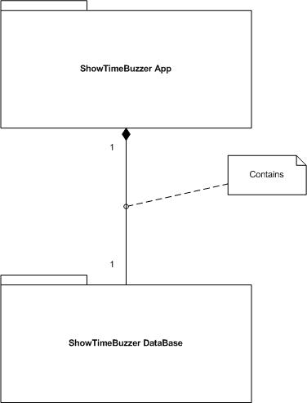

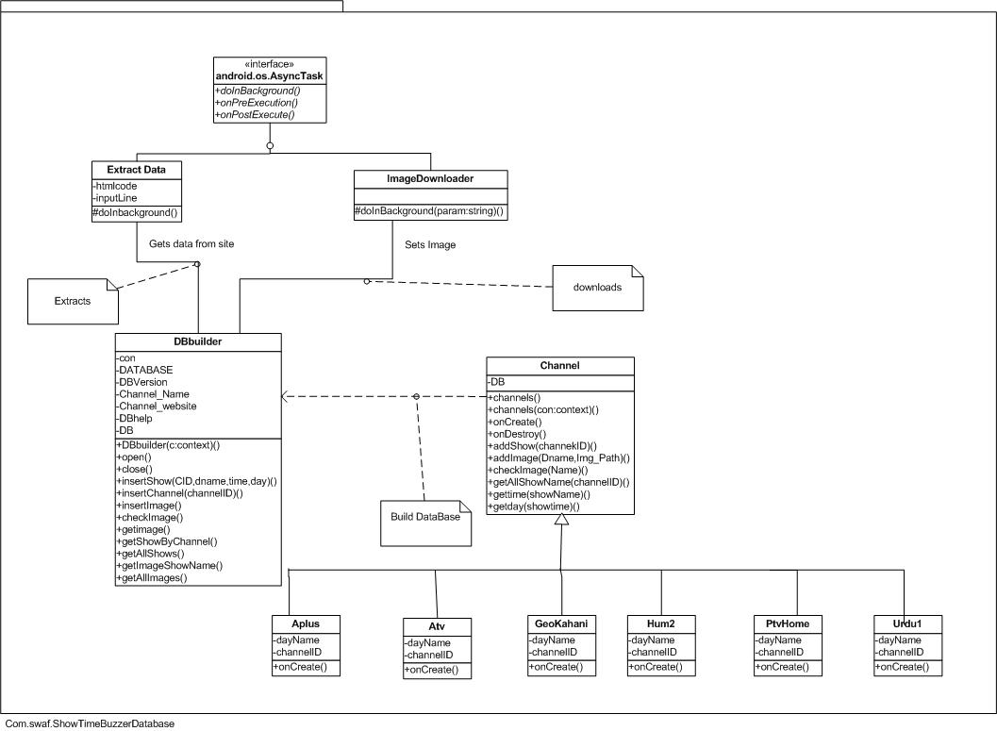

# GLOSSARY

**Channel** The Television channels on which show is on-aired.

**Show** Show refers to dramas and other shows, which are on-aired on Television.

**ShowTime** Time at which show is on-aired.

**Alarm Tone** Ringtone of Alarms set.

**Alarm Time** The time set by user, at which user wants to be alarmed about the show being on-aired, this time must be earlier than the ShowTime.

**Collection** The collection of user’s favorite Shows and Alarm Times.

**Subscribe** Add Show and its timings to user’s Collection of Shows.

**Unsubscribe** Remove Show and its timings from user’s Collection of Shows.